

**CSE 280 ADVANCE JAVA**

**STUDENT WORK BOOK**

|  |  |  |
| --- | --- | --- |
| **Name** | **:** | M.Sathishkumar |
| **Unique ID** | **:** | E0119052 |
| **Year** | **:** | II |
| **Quarter** | **:** | Q6 |
| **Department** | **:** | B.Tech CSE (AI &ML) |
| **Faculty Name** | **:** | Prof. Askoh Kumar |
| **Academic Year** | **:** | 2020-2021 |

**Date:16/11/2020**

**Q.NO 1: Question**

Find the smallest of three numbers

**Program:**

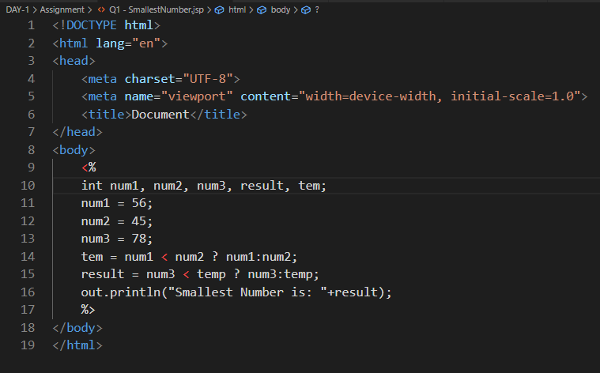

**Output:**

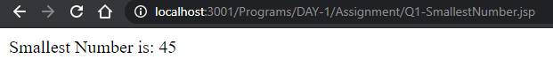

**Date:16/11/2020**

**Q.NO 2: Question**

Calculate the speed when time and distance are given

**Program:**

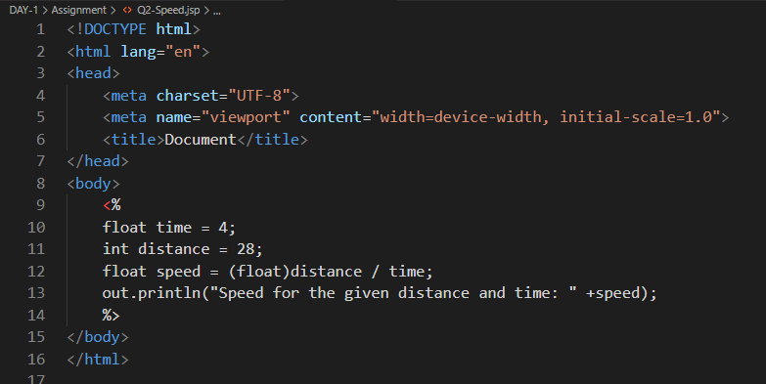

**Output:**

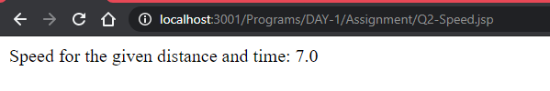

**Date:16/11/2020**

**Q.NO 3: Question**

Find the area of square

**Program:**

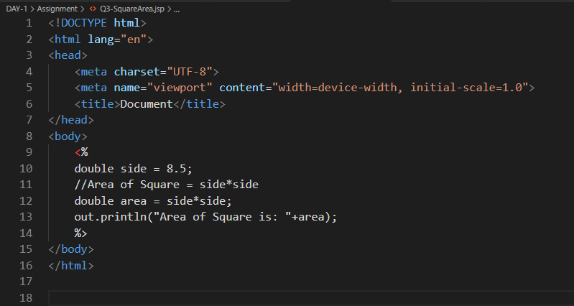

**Output:**

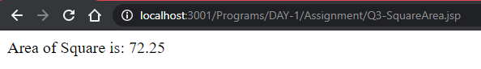

**Date:16/11/2020**

**Q.NO 4: Question**

Find the factorial of a number

**Program:**

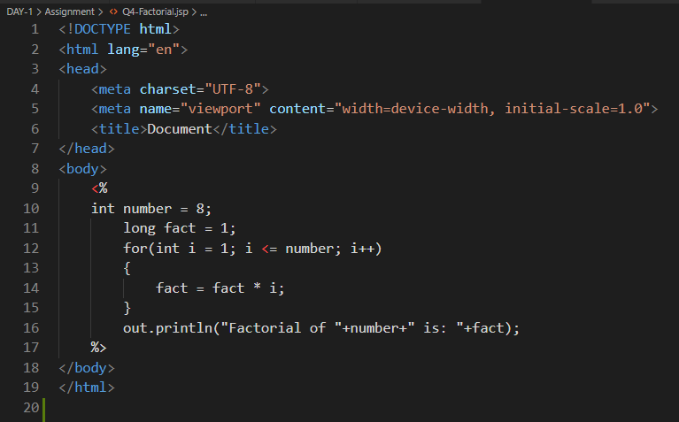

**Output:**

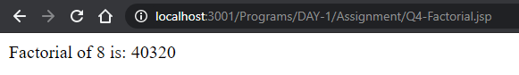

**Date:16/11/2020**

**Q.NO 5: Question**

Find the square root of a number

**Program:**

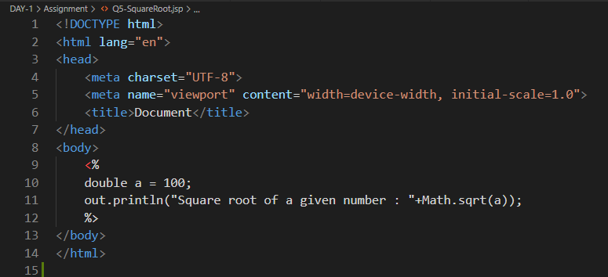

**Output:**

